

Sephora Product Reviews
  - Name: Argang Kazemzadeh
Student Number: 500372885
Supervisor: Dr. Ceni Babaoglu
Date of Submission: 10/09/2025

Table of Contents
Abstract 3
Literature Review 3
Data Description 4

Expletory Data Analysis (EDA) Values: Description 4
Approach 9

Project Methodology Flowchart 9
Research Questions 9
Methodological Steps: 10
GitHub Repository Link 10
References 11

Abstract
This project looks at Sephora customer reviews and product data to find out what makes skincare experiences good and to make models that can guess ratings and feelings. We start by cleaning and exploring the data-checking the rating ranges, getting rid of duplicates, and standardizing the review text. Then we look for important patterns across brands, prices, and user traits like skin type. Next, we make features from both text and metadata. We do this by combining lexical representations (TF-IDF) and transformer embeddings (DistilBERT) with product-level factors (like price and brand) and reviewer context (like review length or skin tone). We compare strong linear baselines like Logistic Regression and SVM with a fine-tuned transformer for classifying sentiment in modeling. We use stratified cross-validation with accuracy, F1, and AUC metrics to evaluate model performance. Then, we do a detailed error and bias analysis to find out where the models are having trouble. The results will give information about both the brand and the attributes. They will also provide a public GitHub repository with a reproducible pipeline that includes code, figures, and documentation.

Literature Review
Recent progress in sentiment analysis and recommendation systems has created new possibilities for their use in the cosmetics industry, but it has also shown that there are still important areas of research that need to be done. Gajula et al. (2025) provide an extensive analysis of sentiment-aware recommender systems in e-commerce, highlighting that the amalgamation of textual sentiment with numerical ratings improves both precision and clarity. Xu (2024) presents a hybrid methodology that integrates dependency parsing with sentiment polarity to derive more resilient attribute labels from product reviews, encompassing those related to cosmetics. Huang et al. (2020) put forward a weakly-supervised joint embedding framework for aspects and sentiments, which lessens the need for big annotated datasets. Agarap (2018) similarly shows that bidirectional LSTM models are better than traditional classifiers at figuring out how people feel about clothing reviews. This shows that numerical ratings are often not good indicators of how people really feel.
In the cosmetics industry, Support Vector Machines (SVM) and Naïve Bayes have been used to look at reviews of beauty products, like those in the Sephora dataset, with accuracies of about 80% to 90%. When customized for beauty and skincare products, newer transformer-based hybrid architectures make classification and aspect extraction even better. These studies demonstrate that although conventional machine learning models continue to be competitive, deep learning and transformer-based models are enhancing the state of the art.
A significant finding in the literature is that Aspect-Based Sentiment Analysis (ABSA) is crucial in the cosmetics sector, where user reviews often discuss various product attributes, including scent, texture, and effectiveness. Nonetheless, limited research incorporates consumer characteristics (e.g., skin type, skin tone) and product metadata (e.g., brand, price) into the sentiment modeling framework. To fill this research gap, this study proposes a cosmetics-specific ABSA and rating prediction model that uses review text, consumer characteristics, and product-level metadata together to give more complete and personalized sentiment insights.

Data Description

Expletory Data Analysis (EDA) Values: Description
There are about 50,000 Sephora product reviews in the dataset, which cover about 1,100 products from more than 120 brands. Each entry has a title, a review text, a 1–5 star rating, brand and product information, a price, and user information like skin type, skin tone, and eye or hair color, as well as metrics for user feedback.
We got rid of bad ratings, duplicates, and made sure that the review text was the same for all of them during data cleaning. The final dataset had about 49,972 reviews after preprocessing. Most users gave high scores, which made the ratings overall positive. The average price of a product was about $45, but some high-end items cost up to $1,900. There were some unusual cases, such as 1,111 reviews for items that cost more than $300, seven reviews that were longer than 500 tokens, and 353 reviews that had more than 100 feedback counts.
There is a positive correlation between ratings and helpfulness (+0.175) and review length (+0.03 to +0.04) and a negative correlation between ratings and feedback counts (−0.10 to −0.17).
Limitations: There are no ingredient lists, so direct ingredient-sentiment analysis is not possible. We will take out proxy features, such as keywords in product names like "retinol" or "SPF."
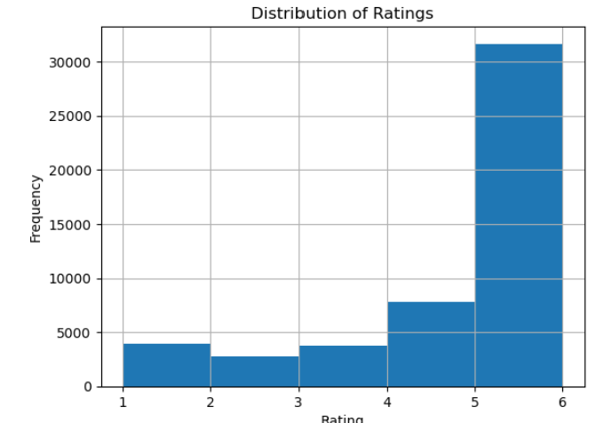
As you can see in Figure 1, most products got very high ratings, with five stars being the most common. There were a lot fewer lower ratings (one to three stars), which made the distribution clearly skewed to the right. This pattern shows that most Sephora customers are very happy with their purchases, but it could also be a sign of a common bias in ratings on e-commerce sites.

Figure 1: Frequency vs Rating.

Figure 2 shows how the length of a review and the rating are related. Most reviews are short, less than 100 words, and have 4–5 stars. This suggests that people tend to give high ratings no matter how long the review is. There is no clear link between longer reviews and higher or lower ratings.

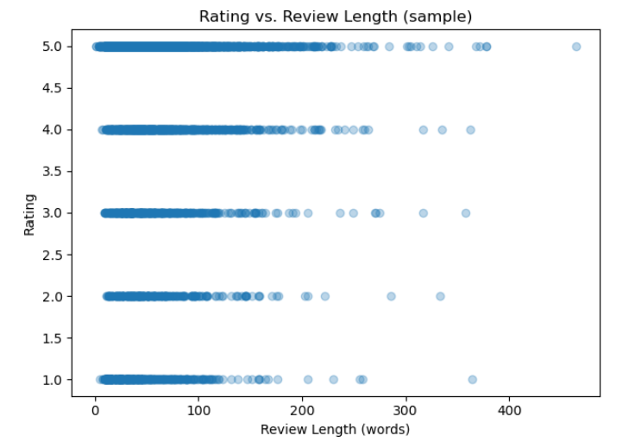
Figure 2: Rating vs Review Length.

The Sephora dataset's numeric features are shown in Figure 3. Most variables, like rating, helpfulness, and price_usd, have small ranges with a few outliers, which means that the data is not evenly spread out. The Unnamed: 0 column has a much wider range, which supports the idea that it's probably just an index field and not real data. The plot shows that there are differences between features and that there are outliers that may need to be normalized or scaled.
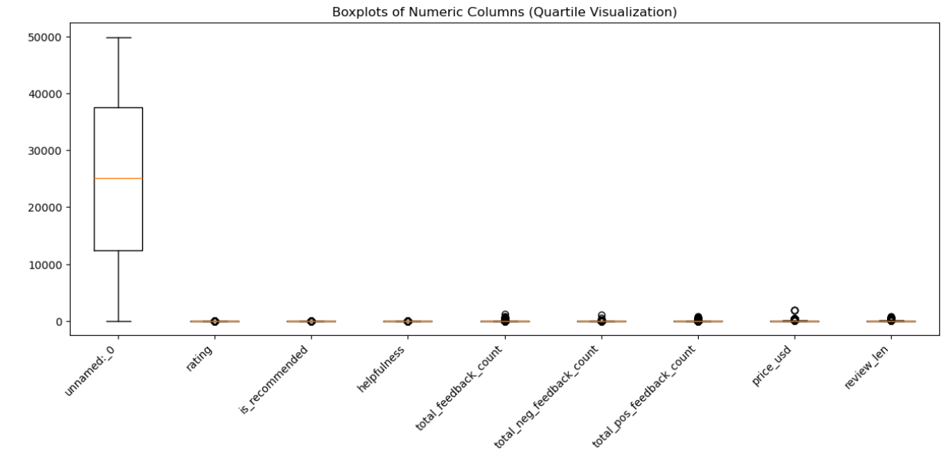
Figure 3: Boxplots of the columns
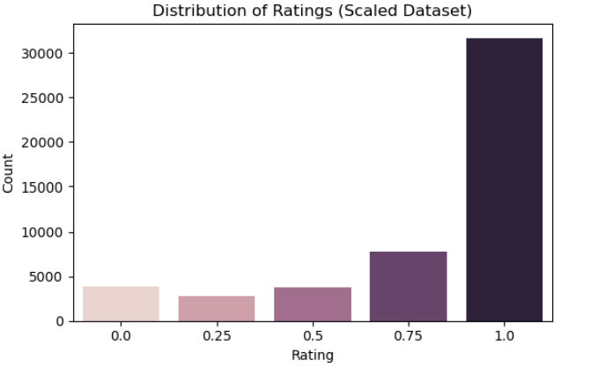
Figure 4 shows how the scaled product ratings are spread out in the Sephora dataset. Most of the ratings are close to 1.0, which means that most users give high scores. This strong right skew suggests that customer feedback is biased in a good way, since negative or moderate ratings are not very common.
Figure 4: Boxplots of the columns

Figure 5 shows a strong positive correlation (0.87) between rating and is_recommended. This means that products with higher ratings are more likely to be recommended.
The feedback-related variables (total_feedback_count, pos, and neg) are also very strongly linked, which shows that users are consistently engaged.
On the other hand, price and helpfulness don't seem to have much of an effect on user scores because they don't seem to be related to ratings.

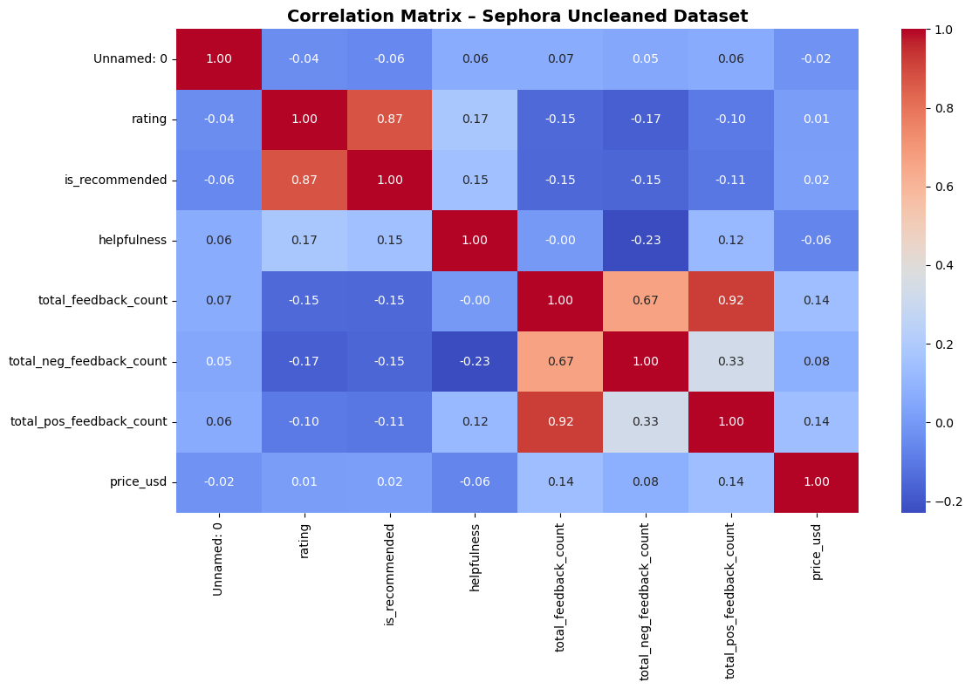

Figure 5: Correlation Matrix

Approach

Project Methodology Flowchart
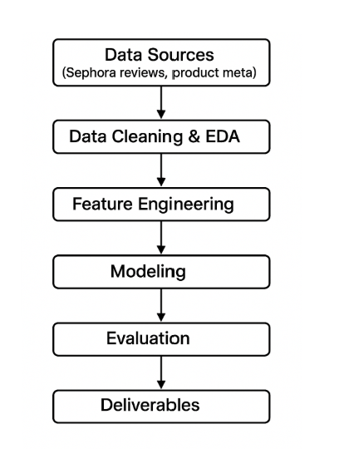
The diagram (Figure 6) illustrates the data science pipeline for the cosmetics review analysis project, showing the sequential flow from data collection to final deliverables.

Figure 6: End-to-end workflow from Data Sources through Deliverables.

Research Questions
- How do sentiment and aspect-level opinions vary across cosmetics categories?
- Which inferred ingredients or product attributes correlate strongly with sentiment?
- Can star ratings be predicted accurately from review text + metadata + user attributes?

Methodological Steps:
1. Text and Feature Engineering: Preprocessing (lowercasing, tokenization), engineered features (review length, punctuation density, all-caps ratio), and lexicon/syntax-based extraction for attributes.
2. EDA: rating distributions, comparisons between brands, sentiment heatmaps at the attribute level, and clustering by attributes.
3. Modeling: Baselines (TF-IDF + LogReg, SVM, Naïve Bayes); Advanced (fine-tuning BERT/DistilBERT). Metadata is included in hybrid models.
4. Evaluation: 5-fold cross-validation, macro-F1, per-class metrics, temporal validation, ablation studies, and error analysis.
5. Contribution: This research builds on previous work by adding consumer attributes, metadata, and inferred ingredients to cosmetics-focused ABSA and rating prediction.
6. Reproducibility: notebooks, configs, dataset versions, and model artifacts will be shared.

GitHub Repository Link

All code, preprocessing scripts, and results will be maintained in a GitHub repository. Please visit the repository at [https://github.com/akazemza/Sephora-BigData-Project]. This ensures full reproducibility and transparency of the workflow, aligned with best practices.

References

- Agarap, A. F. (2018). Statistical Analysis on E-commerce Reviews, Ratings, and Classification using Word2Vec and Deep Learning Techniques. arXiv:1805.03687.
- Devlin, J., Chang, M. W., Lee, K., & Toutanova, K. (2019). BERT: Pre-training of Deep Bidirectional Transformers for Language Understanding. NAACL-HLT.
- Gajula, R., et al. (2025). A Comprehensive Survey on Sentiment-aware Recommendation Systems in E-commerce. arXiv:2505.03828.
- Huang, L., et al. (2020). Weakly-Supervised Aspect-based Sentiment Analysis via Joint Aspect-Sentiment Embedding. arXiv:2010.06705.
- Kim, Y. (2014). Convolutional Neural Networks for Sentence Classification. EMNLP.
- Park, J., & Kim, S. (2020). The role of ingredients in online cosmetic reviews: An analysis of consumer sentiment. Journal of Retailing and Consumer Services, 55, 102120.
- Pontiki, M., et al. (2016). SemEval-2016 Task 5: Aspect-Based Sentiment Analysis. SemEval.
- Xu, Y. (2024). Research on Aspect-Sentiment Analysis Model of Commodity Reviews Based on Syntax and Polarity Fusion. arXiv:2412.15610.
- Zhang, Y., & Chen, X. (2020). Explainable Recommendation: A Survey and New Perspectives. Foundations and Trends in Information Retrieval, 14(1).

